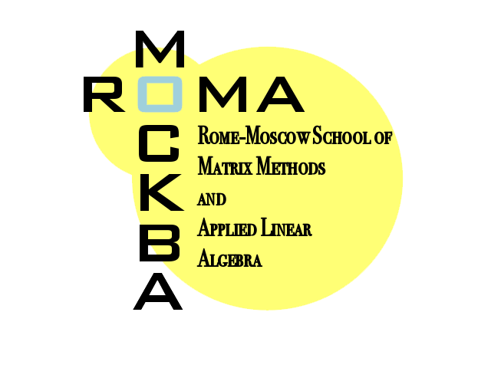
ADVERTISEMENT FOR STUDENTS

Rome-Moscow School of Matrix Methods
and Applied Linear Algebra 2018

August 25 - September 8, 2018,
Lomonosov Moscow State University (LMSU),
Faculty of Computational Mathematics and Cybernetics;
Institute of Numerical Mathematics of the Russian
Academy of Sciences (INM-RAS) of Moscow

September 9 – September 23, 2018,
University of Rome “Tor Vergata” (TV), Department of Mathematics

Supporters
LMSU and TV universities, International Relations Offices
INM-RAS, Gruppo Analisi Numerica di TV, and INdAM (Istituto Nazionale di Alta Matematica)

Aim
The main purpose of the School is to encourage the ideas exchange and the scientific collaborations between Italian and Russian universities and institutions, in the fields of matrix methods and applied linear algebra. The School offers to advanced undergraduate, master’s and PhD students a long time for learning and thinking over scientific research topics, not limited to short courses and seminars, and the opportunity of entering in direct contact with people and institutions of excellence in the field. Attending the courses of the School is equivalent to acquire credits of extra-curriculum activity. The School is organized under an Agreement of didactic-scientific collaboration signed by the Rectors of Lomonosov and Tor Vergata Universities on September 2009, and renewed on September 2014.

Lecturers
Lecturers of the mini-courses of the School will be mainly professors of TV, LMSU and INM-RAS.
There will be also seminars held by professors of other academic and research institutions.

Applications
Italian students should submit application to the e-mail address difiore@mat.uniroma2.it , Russian students to eugene.tyrtyshnikov@gmail.com , and students from other countries to both, following the instructions in www.mat.uniroma2.it/~tvmsscho. Advanced master and PhD students are encouraged to propose a communication on their research field, to be held in a special students session of the school. Estimated lodging expenses for each part of the school: about 250 euros. Estimated meal expenses (in university canteen) for each part of the school: 150 euros. Some modest funds for contributing to students expenses could be available, also for students coming from universities neither of Rome nor of Moscow, provided they obtain good marks in the courses.

Deadline
Applications should be preferably submitted within Wednesday, April 4, 2018, and not later than Monday, April 16, 2018.

Updated information on the school See www.mat.uniroma2.it/~tvmsscho

Rome, February 2018 The professors organizers of the School, Carmine Di Fiore and Eugene E. Tyrtyshnikov

